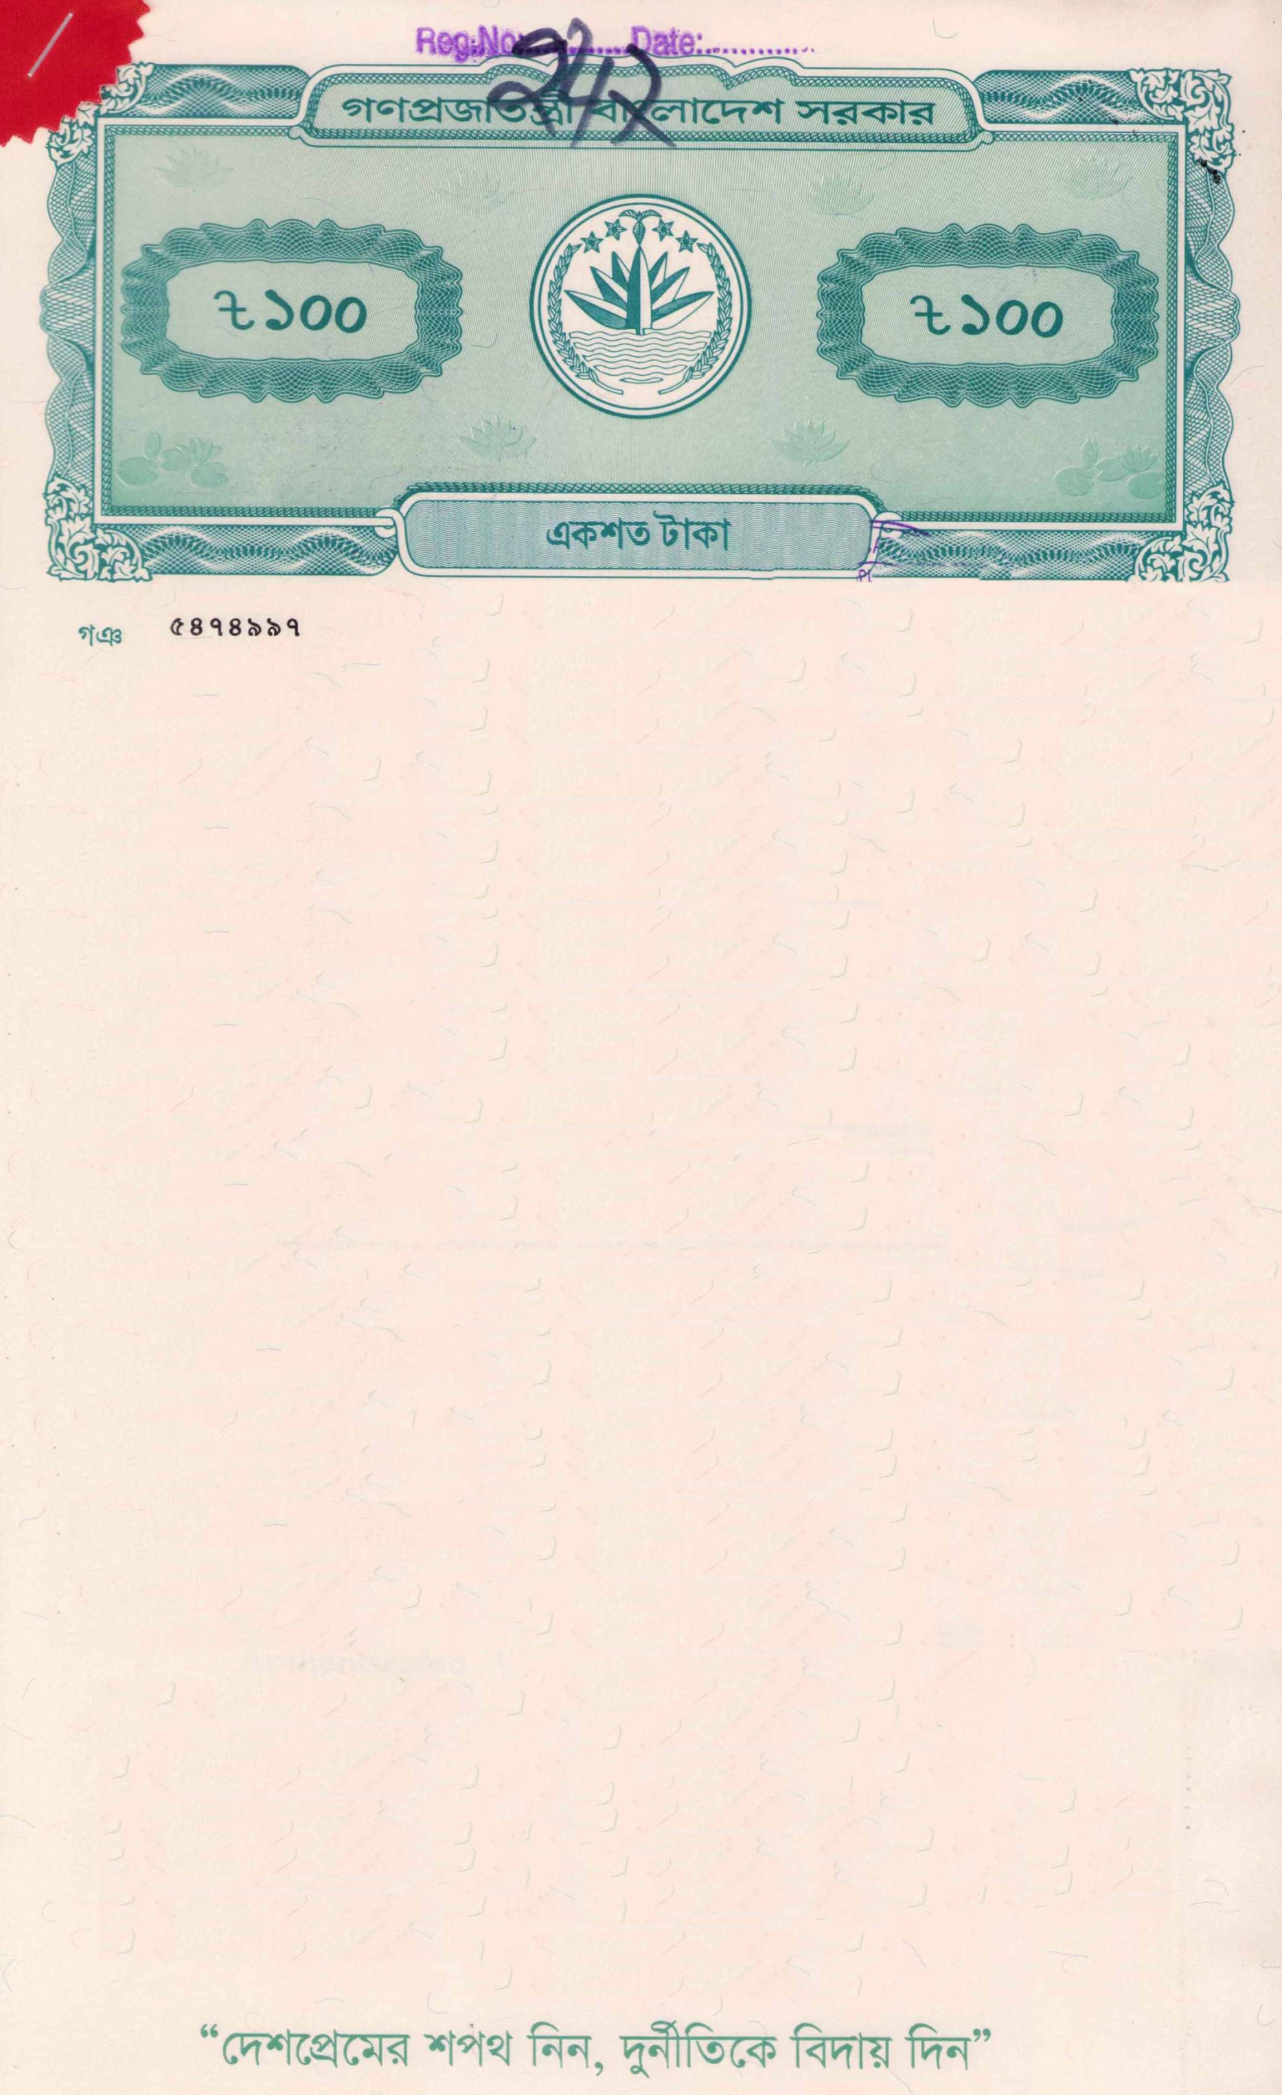




BEFORE THE NOTARY PUBLIC DHAKA, BANGLADESH
AFFIDAVIT OF FINANCIAL SUPPORT
IN FAVOR OF
MAHATHIR ABBAS ROHAN
FOR HIGHER STUDY IN NEW ZEALAND
I, SULTANA NASRIN, Father: Siddikur Rahman, Mother: Lutfun Nesa, Address: Milton Miar Bari, Village/Road: Shobuj Gram, Post Office: Alekzander - 3730, Police Station: Ramgati, District: Lakshmipur. Religion: Islam, Nationality: Bangladeshi, National ID No- 5127306498835, Profession: Business, do hereby solemnly affirm and declare the following that:

- I am the lawful Mother and sole financial sponsor of MAHATHIR ABBAS ROHAN, who has been accepted to pursue higher education in the Bachelor of Information Technology at Auckland Institute of Studies In New Zealand.
- I undertake full financial responsibility for his academic, living, travel, insurance, and incidental expenses throughout the entire duration of his studies in New Zealand.
- I possess sufficient financial resources to support my son's education and stay abroad, and I have demonstrated my liquid funds and financial capacity as demonstrated below.
- These funds originate from my legitimate personal income and savings. I am financially sound and solvent, as verified by my bank, and capable of fulfilling all sponsorship commitments.
- I further undertake to ensure MAHATHIR ABBAS ROHAN completes his full-time academic program as intended and returns to Bangladesh upon the completion of his studies.

Fund Details:
Fund Details | Amount in BDT | Amount in NZD
Account Name: SULTANA NASRIN  Bank Name: Pubali Bank PLC  Account Type: FDR  Account Number: 2966172381112  Fund Origin Date: 12/01/2025 | 6,000,000.00 | 83,379.65
Total Available Funds | 6,000,000.00 | 83,379.65
Source of Fund: Accumulated Savings from Business

(N.B: Rate: BDT 71.96 per NZD as on 21.05.2026)




The Above Stated Funds Came from My Accumulated Income Through the Sources Detailed Below:

Income Details | Annual Income in NZD
Sponsor Name: SULTANA NASRIN  Income Source: Business  Business Type: Brick Kiln  Monthly: BDT 405,000.00 | 67,537.52
Sponsor Name: SULTANA NASRIN  Income Source: House Rent  Rent Type: Monthly  Monthly: BDT 95,000.00 | 15,842.13
Total Annual Income | 83,379.65

Immoveable Asset Details:
Sl. No | PARTICULARS of LAND/PROPERTY: | Present Market Value in BDT  (approximately) | Present Market Value in NZD  (approximately)
a) | I am the owner of Total area: $4\frac{1}{2}$ (Four and a half) decimals Land at Dist- Noakhali, P.S: Noakhali Sadar, Mouza: 95 No Krishnorampur, Mutation Khatian No. 1975 and Deed No- 12305, Date: 15/12/2019 | 85,00,000.00 | 118,121.17
b) | I am the owner of Total area: $4\frac{1}{2}$ (Four and a half) decimals Land at Dist- Noakhali, P.S: Noakhali Sadar, Mouza: 95 No Krishnorampur, Mutation Khatian No. 1697 and Deed No- 254, Date: 16/01/2017 | 84,00,000.00 | 116,731.51
Total Value |  | 16,900,000.00 | 234,852.69

(N.B: Rate: BDT 71.96 per NZD as on 21.05.2026)





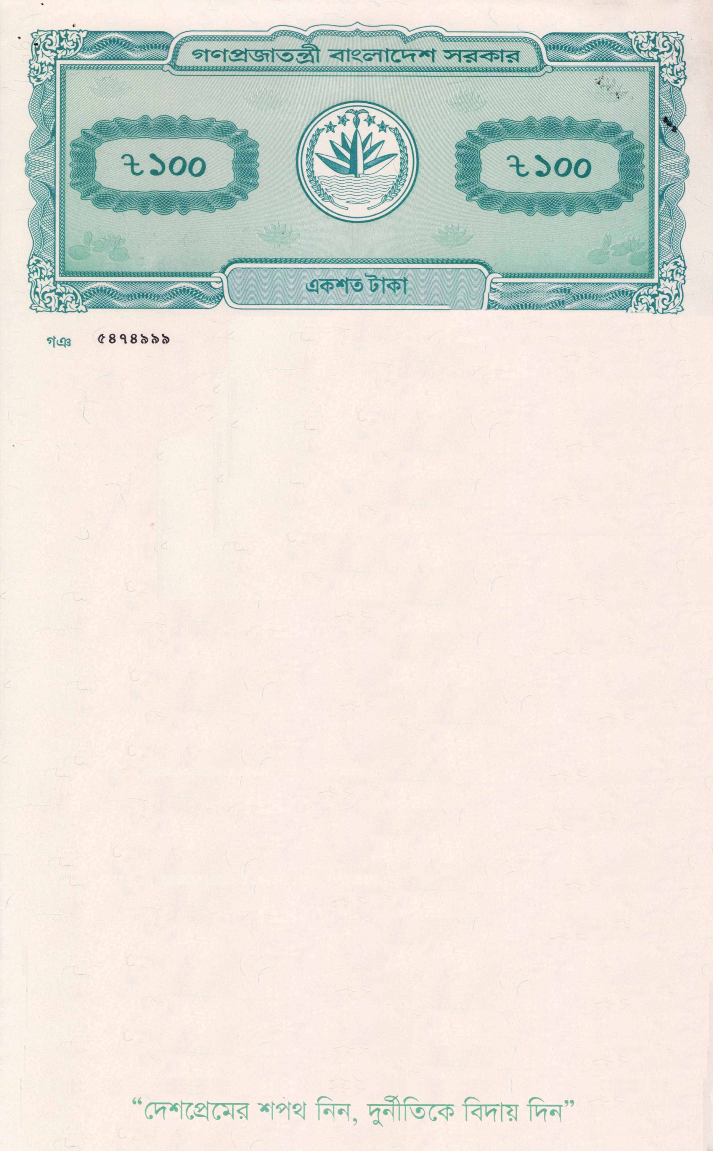

I solemnly affirm that all the above statements are true and correct to the best of my knowledge and belief. In witness whereof, I have executed this Affidavit of Financial Support before the Notary Public in Dhaka, Bangladesh, on this date.

SULTANA NASRIN
(Signatures of Deponents)

The deponent is personally known to me, has been duly identified, and has signed this affidavit in my presence.

